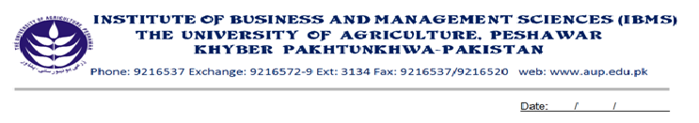
Program: BS (CS)-I
Course Name: Pakistan Studies
Course Code: PK-301
Session: 2012-2015
Credit Hours: 1.5
Total Weeks: 16
Total Hours: 24

Course Objectives
This is a very comprehensive & though-provoking course. It apprises the students of our national independence movement. It has been so designed as to develop among the students the feeling of Pakistani patriotism, Islamic nationalism, and pan-Islamism.
Its purpose is to create among student some of pride about the historical legacy of our glorious past. It aims at creating among them awareness about various phases of our struggle for independence from both the British rule and Hindu majority domination. It also apprises about the rational of achieving an independent & separate Islamic State, about the tremendous sacrifices our ancestors and the urgency of the they establishment of an Islamic egalitarian society in Pakistan based on the Islamic principles of equality brother hood, justice and tolerance.
Week-1 The Pakistan ideology, its definition and explanation
Importance of Pakistan ideology in the life.

Week-2 The Pakistan ideology in the light of words of Allama Iqbal and Quaid-e-Azam
The aims and objectives of the establishment of Pakistan

Week-3 The Historical background of Pakistan ideology
The Reformists-Shiekh Ahmed Sir Hindi,
Shah Walliullah and others

Week-4 Education Reforms-Aligareh
Anjuman Himayat-i-Islam
Sindh Madrasah, Islamia College, Peshawar

Week-5 Constitutional Reforms of 1909, 1919 & 1935 act of India
Khilafat movement

Week-6 The Pakistan movement
Muslim National movements and Education of Pakistan ideology
The problem of independence of India and the Muslims
Week-7 Allama Iqbal’s Address 1930 at Allahabad
The 1937 Elections and attitude of Congress Ministries

Week-8 The Pakistan Resolution of 1940
The1946 elections and transfer of powers

Week-9 Emergence of Pakistan
Important events and hurdles at the time of emergence of Pakistan
Effort of Government to overcome these hurdles

Week-10 Creating an Islamic order in Pakistan
The objective resolution of 1949

Week-11 The Islamic clauses in the of Pakistan Constitutions of 1956, 1962 & 1973
The preliminary steps for Islamic order
The Goals. The complete Islamic order.

Week-12 The Land of Pakistan
Geographical unity
Location of Pakistan geographical importance
Rural and Urban areas features, problems, etc

Week-13 Natural resources of Pakistan-importance
Agriculture-importance problems and measures for solution

Week-14 Industry-Importance problems and measures for solution
Exports and Disports-problems and measures for solutions
Manpower-Problems for solution

Week-15 Pakistan and Islamic world
Relations with Islamic countries
Pakistan’s relations with neighboring countries

Total Marks: 100
Recommended Books:
- M.D. Zafar, Pakistan Studies, Aziz Book Depot, Lahore.
- Pakistan Studies for Degree Classes, Allama Iqbal Open University, Islamabad.
- Prof: Fazli Wahid Standard Pakistan Studies, 2003, IBMS/CS, N.W.F.P. Agricultural University, Peshawar

